LAPORAN
WORKSHOP DEVELOPER OPERATIONAL
MINGGU-9



oleh:
Kelompok Devora
Luthfan Dawami Ahmad E41232326
Jimmy Damai Pribadi E41232072
M. Zidane Julian Saputra E41232150
Redrigo Frans Danu Arta E41232149
M. Alvyn Akbar E41232243
Devi Zahra Safrida E41232170

PROGRAM STUDI TEKNIK INFORMATIKA
JURUSAN TEKNOLOGI INFORMASI
POLITEKNIK NEGERI JEMBER
2026

- M. Zidane Julian as a manager
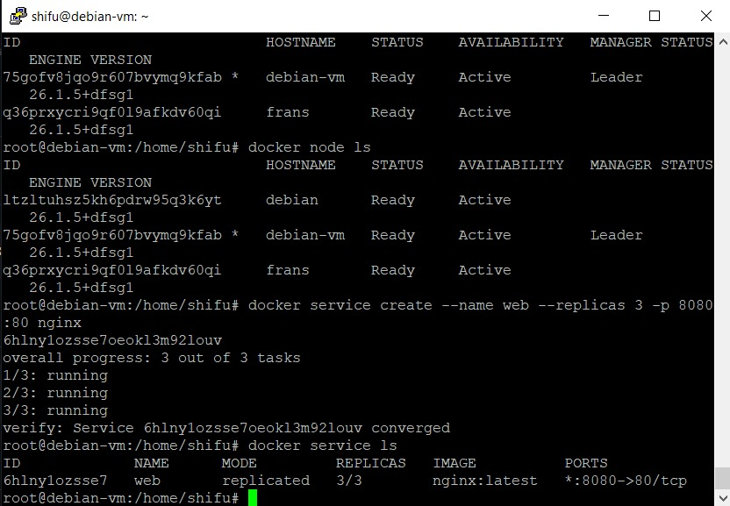
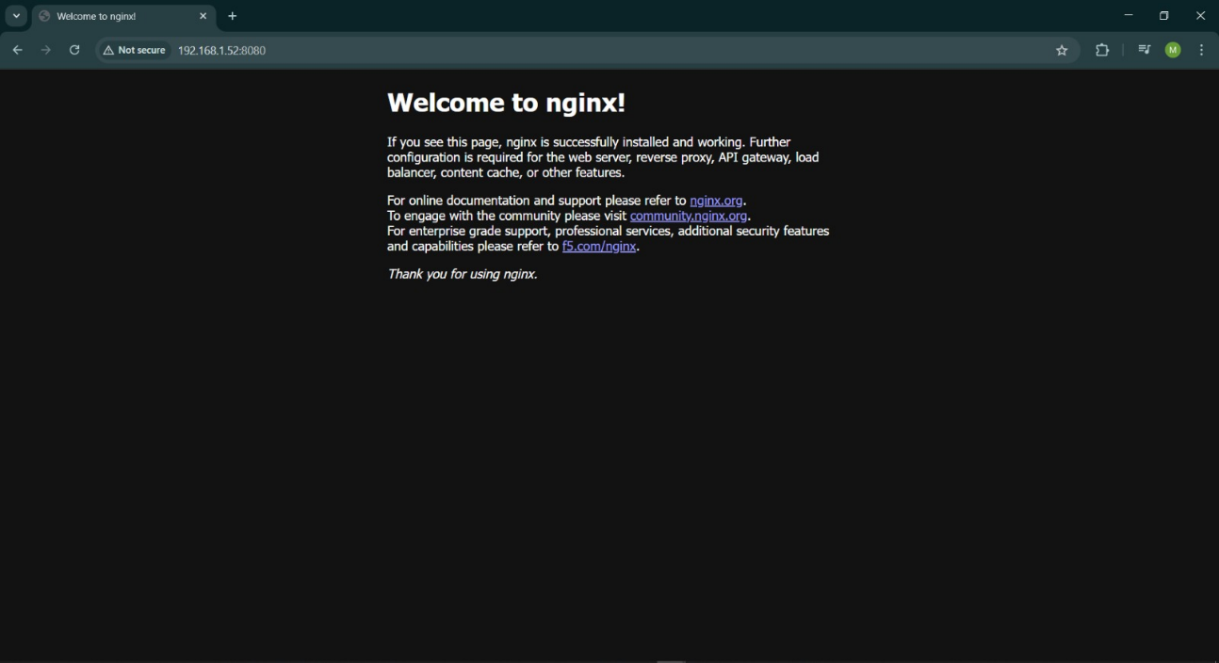
- Redrigo Frans as a worker
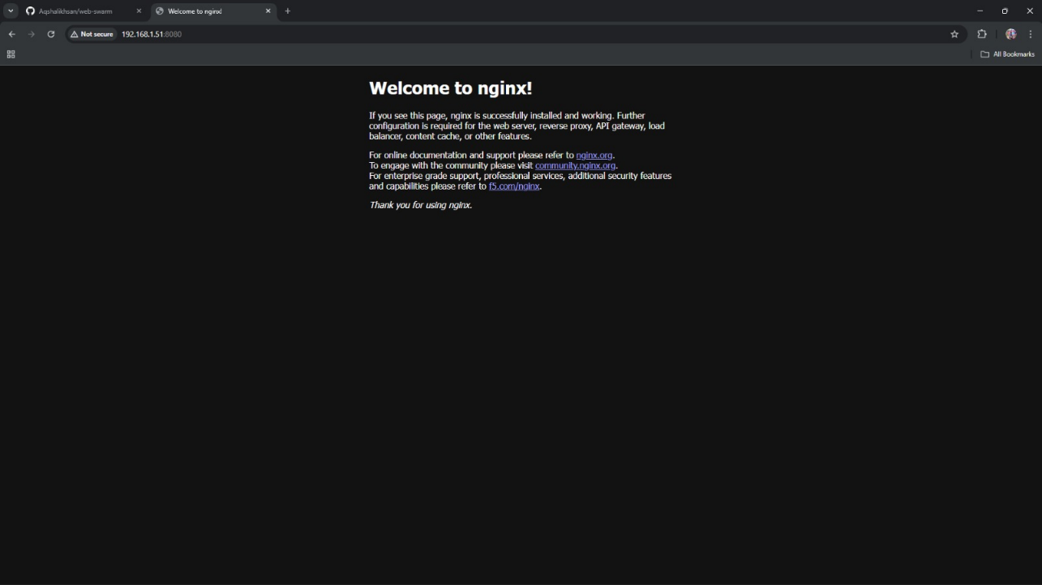
- M. Alvyn Akbar as a worker
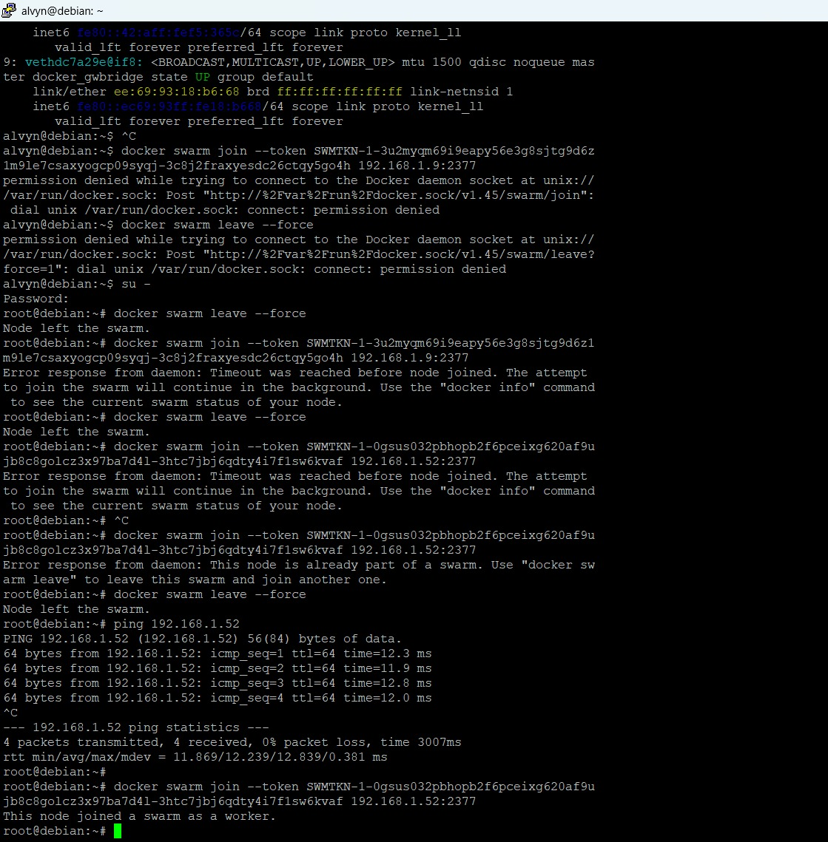
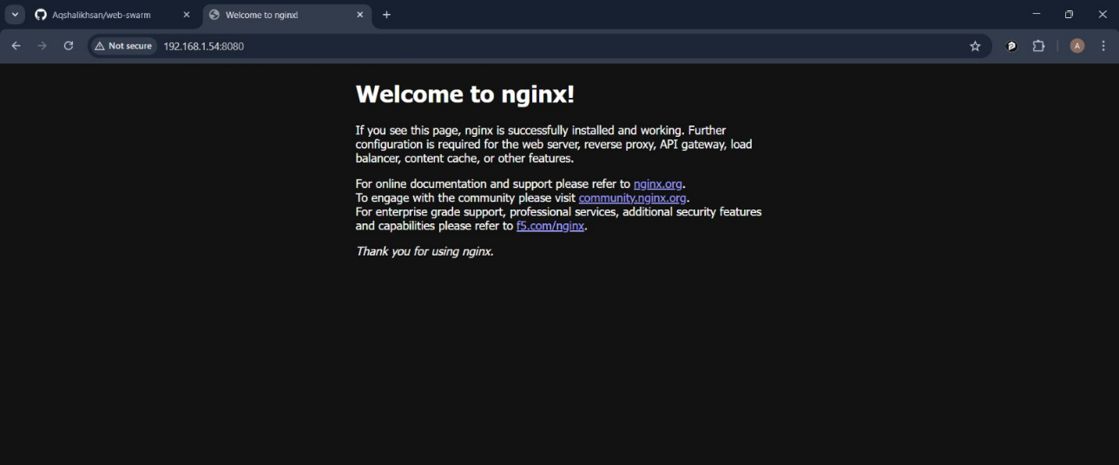
- Devi Zahra Safrida as a worker
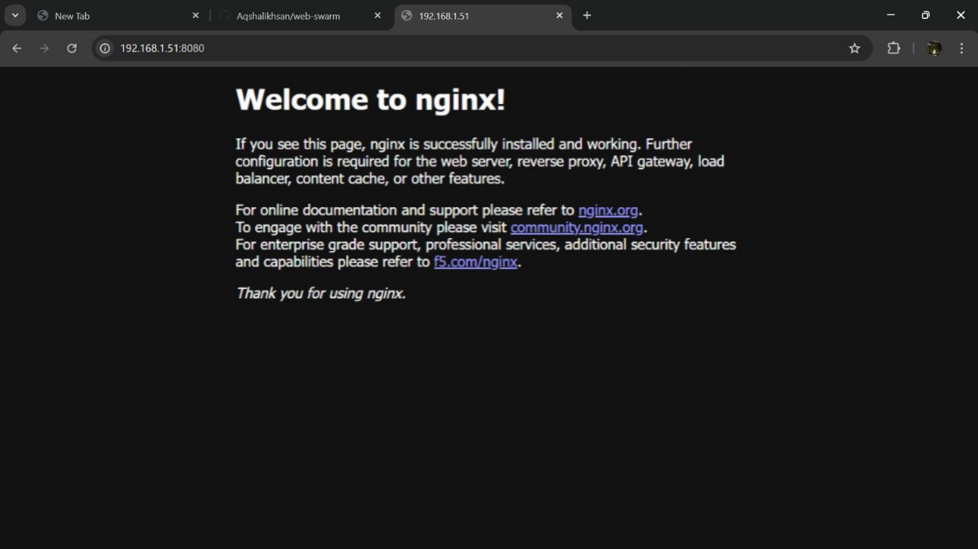
- Jimmy Damai as a worker
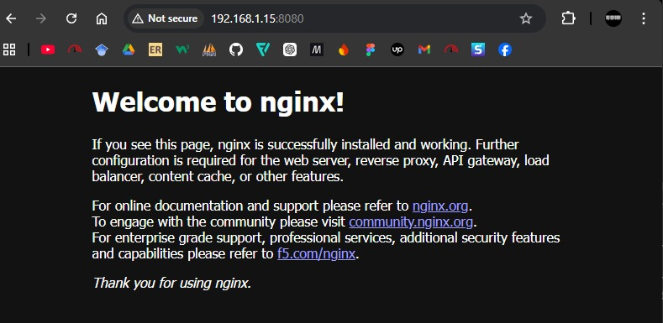
- Luthfan Dawami as a worker
